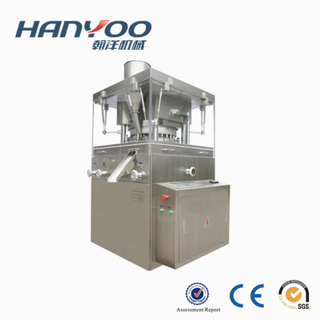  Share to： | ZP-35/37D Automatic Rotary Tablet Press Machine  Model： ZP-35/37D  Name： Automatic Rotary Tablet Press Machine

Detail
APPLICATION
The machine is a double pressing automatically revolving piece-pressing machine which could make grain be
pressed to be round pieces, be carved characters, special shapes and double color piece prescription. It is mainly
used in manufacturing piece prescription for pharmaceutical industry enterprises like chemical, food, electronics.

FEATURE
1. The inner machine surface already be special treated, which could keep surface luster and prevent from being
polluted crossly.
2. Equipped with over-load protection apparatus. When pressure overloads, the machine stop automatically.
3. Power suction unit is attached to take the residual power during operation so that the blockage powder can be
collected and be reused.

TECHNICAL PARAMETER
Model | ZP-35D | ZP-37D
Dies | 35 | 37
Max. Pressure (KN) | 80 | 80
Max. Tablet Dia. (mm) | 13 | 13
Max. Filling Depth (mm) | 15 | 15
Max. Thickness (mm) | 6 | 6
Production Capacity (pcs/h) | 150000 | 160000
Motor (KW) | 4 | 4
Overall Dimensions (mm) | 980×1240×1690 | 980×1240×1690
Net Weight (KG) | 1700 | 1700

