SJ-2L Automatic Suppository Packing Machine
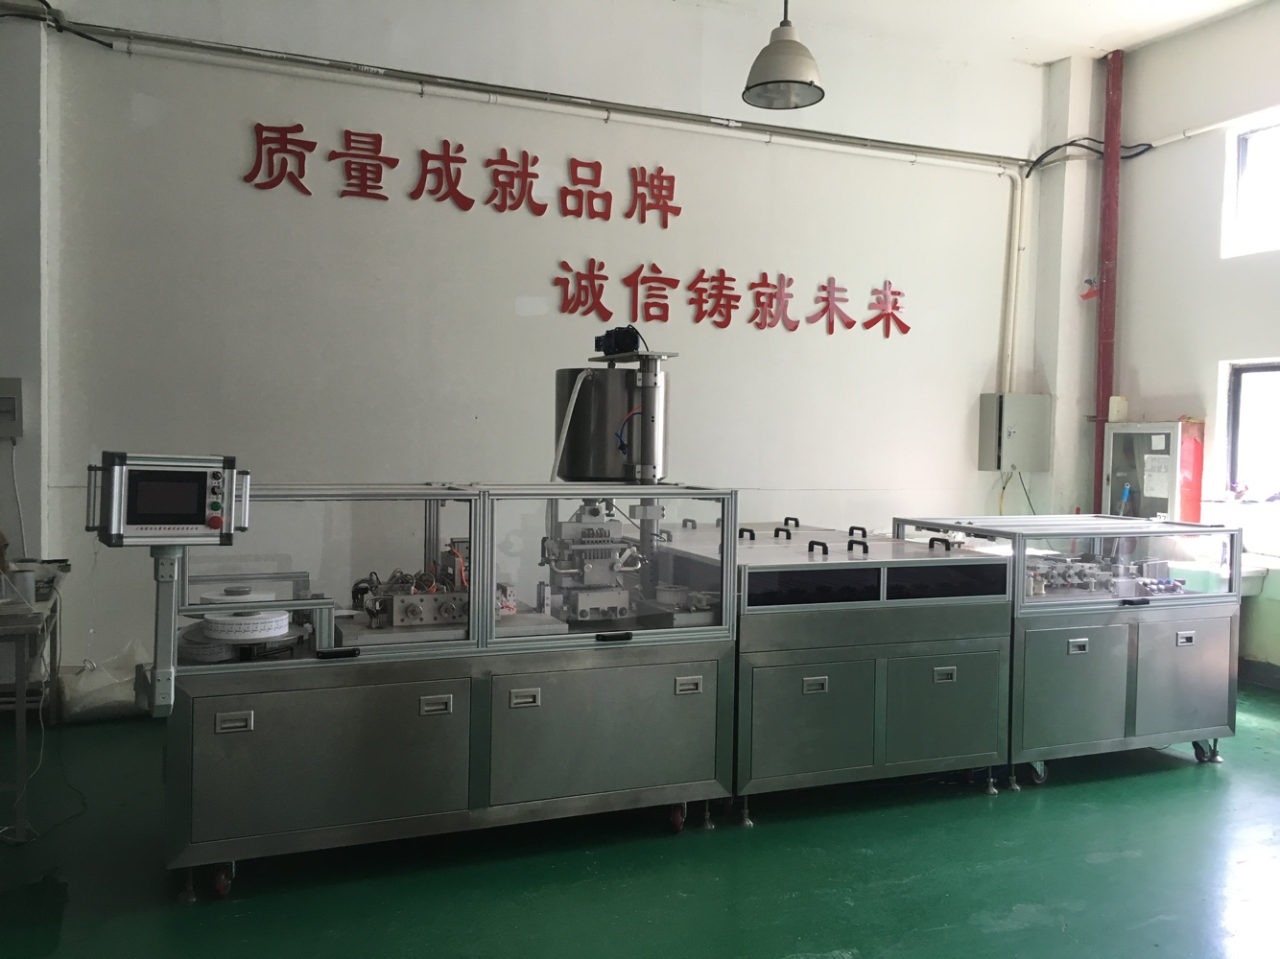

Product Name | Suppository Line | Model | SJ-2L
Output | 3000-3600 pcs/h | Dosage | 0.5—5ml
Dosage allowed | ＜±2% | Packaging Film | PVC PVC\PE  Thickness 0.15mm
Storage of the liquid barrel | 20L | Atmospheric pressure | ≥0.6Mpa
Consume the tolerance | 1.0m³ | Water quantity | 50kg (Circling)
Voltage | 380V | Total power | 3KW
Shapes | Different | Weight | 500kg
Dimension | 2000×1500×1600 | Each distance of suppository | 17.4mm

Electronic Part List
No. | Name | Brand
1 | PLC | Siemens
 | Communication module | Siemens
 | Temperature Module | Siemens
2 | Touch Screen | Siemens
3 | Frequency Convetor | Schneider
4 | Breaker | Schneider
5 | Temperature Control | Yudian
6 | Solenoid Valve | AirTAC
7 | Sensor | Schneider
8 | Alarming Buzzer | China
Price 72000$ CIF

